Cost Function and Gradient Descent

1️⃣ What is a Cost Function?
A cost function measures how far off our predictions are from the true values.
In regression, the most common cost function is Mean Squared Error (MSE).
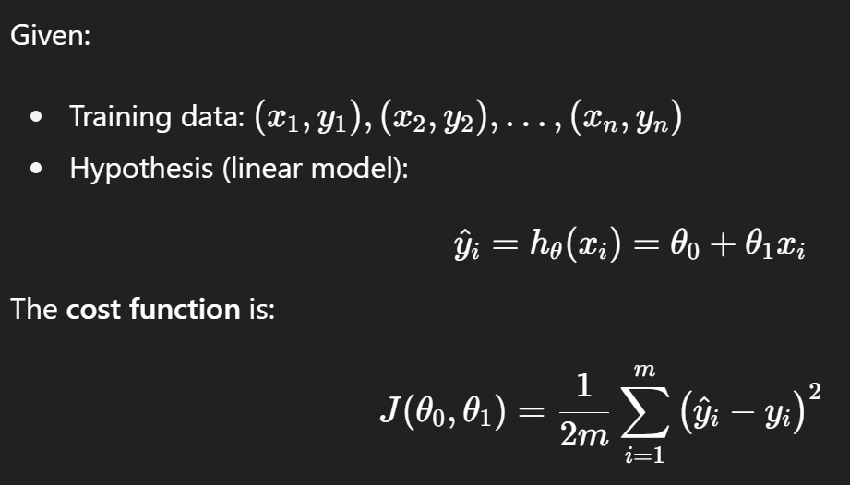
Why squared error?
- Always non-negative → no cancellation between positive & negative errors.
- Smooth & differentiable → allows calculus-based optimization.
- Penalizes large errors more → model focuses on fixing them.
(Sometimes MAE or other losses are used, but MSE is the classic starting point.)

2️⃣ Gradient Descent: Intuition
We want to minimize the cost function J(θ).
But there is no closed-form solution (except in OLS normal equations), so we use Gradient Descent (GD).
Idea:
- Imagine J(θ) is a hill.
- The gradient (slope) tells us the steepest upward direction.
- To minimize cost, we move in the opposite direction of the gradient.

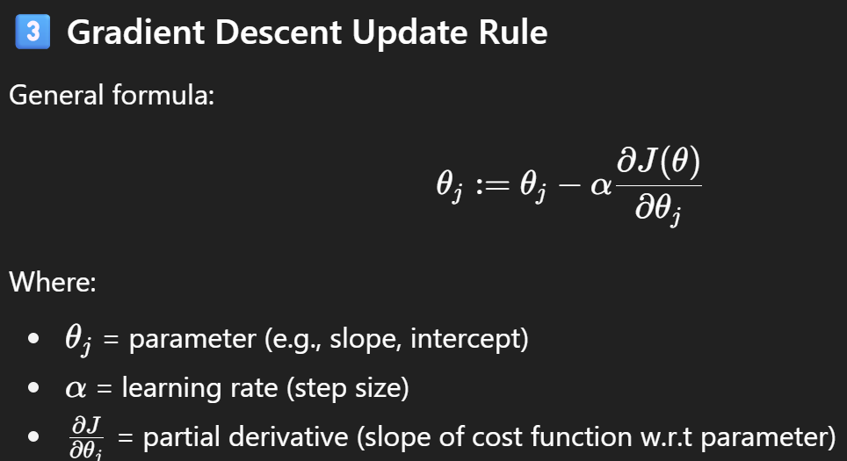
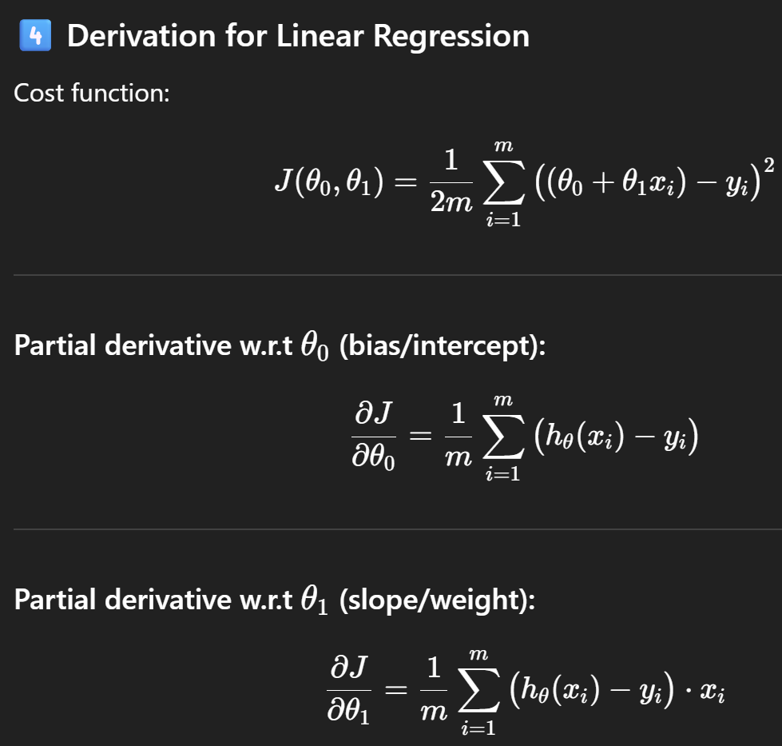
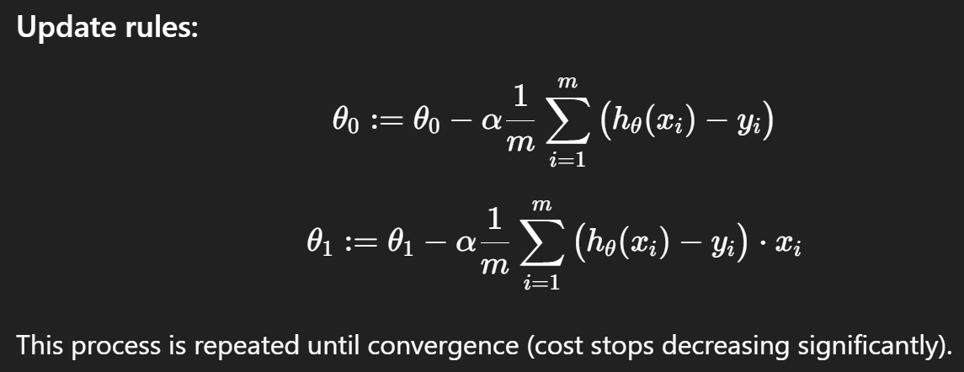
5️⃣ Learning Rate (α)
- If α is too small → very slow convergence.
- If α is too large → algorithm may diverge (overshoot minima).

6️⃣ Types of Gradient Descent
- Batch Gradient Descent
  - Uses all training examples per step.
  - Very stable, but slow on large datasets.
- Stochastic Gradient Descent (SGD)
  - Uses one random training example per step.
  - Much faster, but noisier updates.
  - Helps escape local minima.
- Mini-batch Gradient Descent
  - Uses small batch (e.g., 32, 64 samples).
  - Balance between Batch GD and SGD.
  - Most common in practice (especially in DL).

7️⃣ Geometric View
- The cost function for linear regression (MSE) is a convex paraboloid (bowl-shaped).
- GD always converges to global minimum (no local minima issue in linear regression).

8️⃣ Visualization Example
Imagine trying to fit a line:
- Start with random θ0​,θ1​.
- Compute gradient.
- Adjust θ
- Line gradually tilts/shift until it best fits the data.
- Cost function decreases step by step.

✅ Summary in Plain Words:
- Cost function tells us how wrong our model is.
- Gradient Descent is the method to tweak parameters in small steps, downhill on the cost curve, until we reach the best fit.

